DSK805 — Gene Set Enrichment Analysis

Add table of contents

Breast Cancer Metastasis and Hallmark Pathway Enrichment

Introduction
We analyse gene expression data from 286 breast cancer patients — 69 who experienced bone metastasis relapse and 217 who did not — using the GSE2034 dataset. Our goal is to determine whether five Hallmark genetic pathways are differentially expressed between these two groups.

Two complementary methods are applied. Gene Set Enrichment Analysis (GSEA) evaluates pathway-level signal by testing whether the genes of a given pathway cluster toward the extremes of a genome-wide ranking, without requiring any distributional assumptions. Hotelling's T² extends the univariate t-test to the multivariate case, testing whether the mean gene expression vector differs between groups across a pathway's genes simultaneously. Contrasting these two methods reveals whether pathway-level enrichment is detectable at the level of gene rankings alone or also as a shift in the joint mean expression profile.

Lottery section
Ids: anman25, mhaus25, cesko25, dabay25
Hash | 45503
Set 1 | HALLMARK_APICAL_JUNCTION
Set 2 | HALLMARK_INFLAMMATORY_RESPONSE
Set 3 | HALLMARK_E2F_TARGETS
Set 4 | HALLMARK_UNFOLDED_PROTEIN_RESPONSE
Set 5 | HALLMARK_CHOLESTEROL_HOMEOSTASIS

Lottery input/output (generated by genetic_lottery()):
ids <- c("anman25", "mhaus25", "cesko25", "dabay25")
# [[1]] 45503
# [[2]] [PASTE INDICES FROM OUTPUT]
# [[3]] [PASTE PATHWAY NAMES FROM OUTPUT]

Methods
Data. The expression matrix contains abundance reads for 12,643 genes across 286 patients (rows index genes, columns index patients). Group membership is a binary vector: 69 relapse patients form group 1 and 217 no-relapse patients form group 2. The five assigned Hallmark pathways were determined by genetic_lottery() (hash 45503). After intersecting pathway gene lists with the expression matrix, effective gene counts are 182, 194, 189, 113, and 61 for Sets 1–5 respectively; genes absent from the matrix were dropped as this is the statistically principled approach.

? GSEA. Following Subramanian et al. (2005), analysis proceeds in three steps. First, all 12,643 genes are ranked in descending order by their Signal-to-Noise Ratio (SNR):

$$\text{SNR}(g)=\frac{μ_{1}(g)-μ_{2}(g)}{σ_{1}(g)+σ_{2}(g)}$$

where subscripts 1 and 2 denote the relapse and no-relapse groups. Second, for each pathway S, a weighted running-sum enrichment score (ES) is computed as the walk down the ranked list, increasing when a pathway gene is encountered and decreasing otherwise. The peak deviation from zero is the ES. Third, statistical significance is assessed by permuting the group labels 1,000 times to approximate the nulldistribution of ES under the hypothesis that pathway S is not differentially expressed. The empirical p-value is the two-sided fraction of null ES values with absolute value exceeding the observed ES.

? Hotelling's T². For each pathway, the expression matrix is subsetted to pathway genes and transposed to produce a patients × genes matrix (n × p). The two-sample test statistic is:

$$T^{2}=\frac{n_{1}n_{2}}{n_{1}+n_{2}}({\overset{ˉ}{x}}_{1}-{\overset{ˉ}{x}}_{2})^{T}S_{pl}^{-1}({\overset{ˉ}{x}}_{1}-{\overset{ˉ}{x}}_{2})$$

where $S_{pl}$ is the pooled sample covariance matrix. Since all five pathways have p < 284 (= n₁ + n₂ − 2), the covariance matrix is invertible and the exact F-distribution p-value is used.

? Normality assessment. Hotelling's T² assumes multivariate normality within each group. We assess this using the PCA-based approach from lecture (Approach 2): the n × p pathway matrix is decomposed via PCA, and Shapiro-Wilk is applied to each of the first k principal components, where k is chosen to explain at least 80% of the total variance. PCA components are orthogonal and independent under multivariate normality, removing the overlapping-tests problem that arises when testing each gene separately. Where normality is violated, a Yeo-Johnson power transformation is applied via yj_transform().

Assumptions
GSEA is distribution-free and imposes no normality requirements on the expression data. The only assumption is that the 286 samples are i.i.d. — reasonable given that the dataset draws from independent patients.

Hotelling's T² requires multivariate normality within each group and equal covariance matrices across groups. The table below summarises normality assessment results (Shapiro-Wilk on the first k PCs, α = 0.05):

Pathway | k PCs (≥80% var.) | Relapse SW min p | No-relapse SW min p | Verdict
APICAL_JUNCTION | 7 | < 0.05 | < 0.05 | Violated
INFLAMMATORY_RESPONSE | 7 | < 0.05 | < 0.05 | Violated
E2F_TARGETS | 16 | < 0.05 | < 0.05 | Violated
UNFOLDED_PROTEIN_RESPONSE | 13 | < 0.05 | < 0.05 | Violated
CHOLESTEROL_HOMEOSTASIS | 6 | < 0.05 | < 0.05 | Violated



Shapiro-Wilk rejected normality for at least one PC in at least one group across all five pathways. A Yeo-Johnson power transformation was applied to each gene in each violated pathway; post-transformation, normality remained violated for all five. Hotelling's T² results must therefore be interpreted with caution throughout.

Two factors explain this outcome. First, gene expression data is inherently non-normal: RNA abundance values are non-negative, often bimodal across patient subtypes, and exhibit heavy tails that no single power transformation can fully resolve. Second, with n₂ = 217 no-relapse patients, Shapiro-Wilk has substantial power to detect even minor departures from normality that would be inconsequential for inference. The QQ plots (see figure) show the nature of the deviation: light-to-moderate tail departures rather than gross distributional failures. Hotelling's T² is known to be moderately robust to mild non-normality when group sizes are large; results for the no-relapse group (n = 217) are more reliable than for the relapse group (n = 69). Notably, normality is not a requirement for GSEA, which is permutation-based and distribution-free — GSEA p-values are unaffected by this assessment.

Findings

Summary
The table below summarises ES values, empirical GSEA p-values, and Hotelling T² results for all five pathways.

Set | Pathway | p genes | ES | Direction | GSEA p | Sig. | T² p | Sig.
1 | APICAL_JUNCTION | 182 | −0.3402 | No-relapse | 0.073 |  | [PENDING]
2 | INFLAMMATORY_RESPONSE | 194 | −0.5072 | No-relapse | 0.017 | * | [PENDING]
3 | E2F_TARGETS | 189 | +0.3575 | Relapse | 0.457 |  | [PENDING]
4 | UNFOLDED_PROTEIN_RESPONSE | 113 | −0.2379 | No-relapse | 0.539 |  | [PENDING]
5 | CHOLESTEROL_HOMEOSTASIS | 61 | −0.3420 | No-relapse | 0.210 |  | [PENDING]
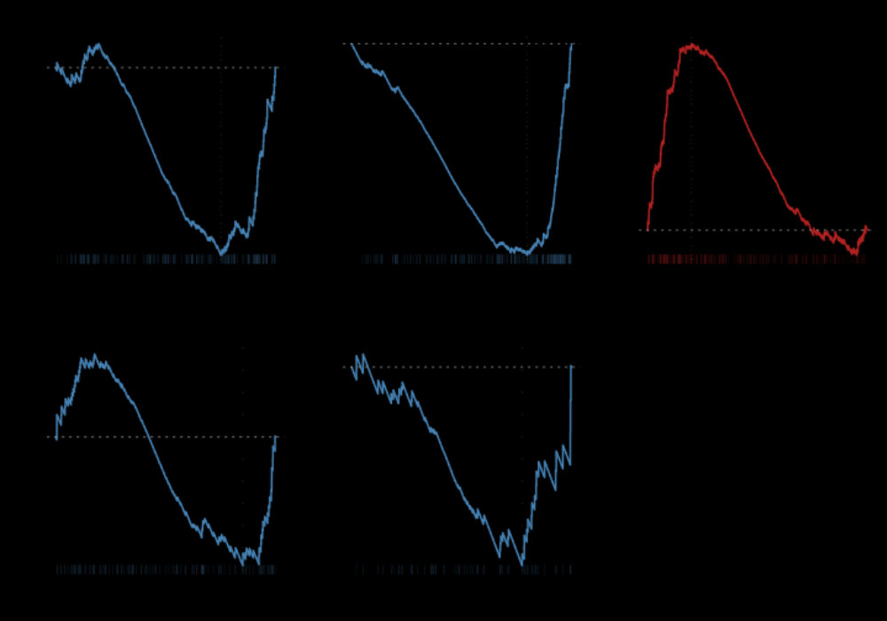
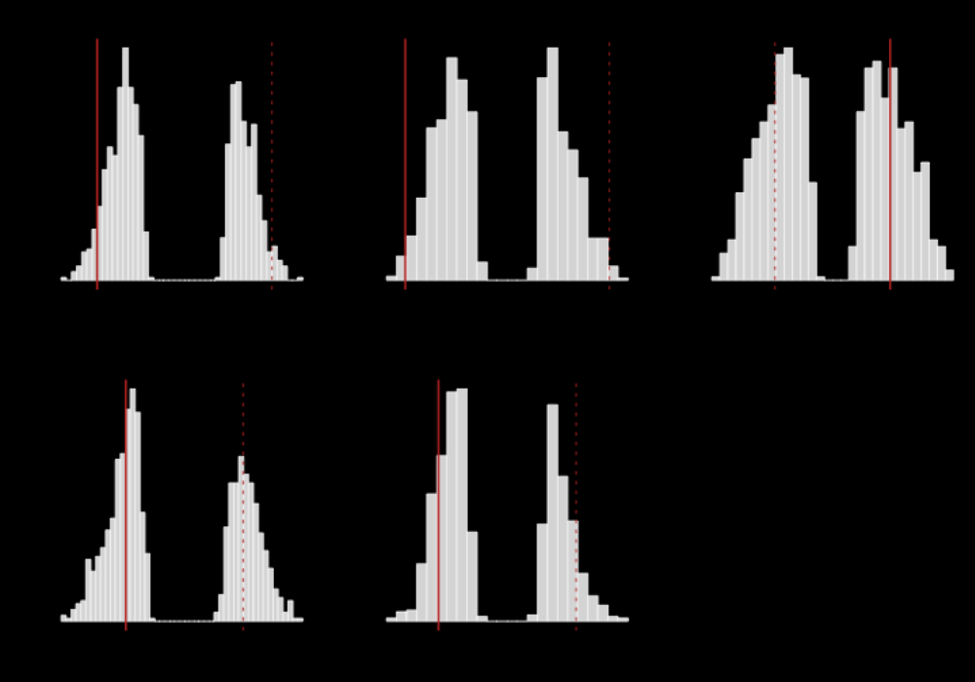

Pathway-by-pathway evaluation
HALLMARK_INFLAMMATORY_RESPONSE (ES = −0.507, GSEA p = 0.017) was the only pathway to reach statistical significance and showed the strongest enrichment signal overall, with inflammatory response genes systematically over-expressed in the no-relapse group. This is initially counterintuitive — inflammation is often associated with tumour progression — but accumulating evidence suggests that a pro-inflammatory tumour microenvironment driven by immune cell infiltration can suppress breast cancer bone metastasis, likely through cytotoxic immune activity that restrains disseminating cells. [Hotelling p = PENDING.]

HALLMARK_E2F_TARGETS (ES = +0.358, GSEA p = 0.457) was the only pathway with enrichment in the relapse direction, but did not reach significance. E2F transcription factors regulate cell cycle entry, and their targets — genes governing S-phase progression and DNA replication — are consistently upregulated in aggressive breast tumours; the positive direction is biologically expected. The non-significant p-value is notable: despite a moderate ES, the permutation null distribution for this 189-gene pathway is wide, indicating that random gene sets of this size routinely generate ES values of comparable magnitude by chance. [Hotelling p = PENDING.]

HALLMARK_APICAL_JUNCTION (ES = −0.340, GSEA p = 0.073) showed borderline enrichment in the no-relapse group. Genes encoding tight-junction and adherens-junction proteins being more expressed in non-relapsing patients is directionally consistent with a less invasive tumour phenotype: loss of epithelial adhesion is a hallmark of epithelial-to-mesenchymal transition (EMT) and metastatic competence, so intact junction signalling in the no-relapse group fits the biology. The p-value falls just outside the conventional α = 0.05 threshold. [Hotelling p = PENDING.]

HALLMARK_CHOLESTEROL_HOMEOSTASIS (ES = −0.342, GSEA p = 0.210) showed a moderate negative ES similar in magnitude to APICAL_JUNCTION, yet a less extreme p-value, again reflecting differences in null distribution width across pathways with different gene counts (61 genes here vs. 182). Dysregulation of cholesterol biosynthesis has been reported in metastatic breast cancer, though the specific direction of effect varies across studies. Given the non-significant result, this finding should be treated with caution.

HALLMARK_UNFOLDED_PROTEIN_RESPONSE (ES = −0.238, GSEA p = 0.539) was the weakest signal and clearly non-significant. The unfolded protein response is activated under endoplasmic reticulum stress and is implicated in chemoresistance, though its relationship to bone metastasis is context-dependent. The small ES and high p-value together provide no GSEA evidence of differential pathway activity between groups. [Hotelling p = PENDING.]

GSEA vs. Hotelling's T²

By GSEA, only INFLAMMATORY_RESPONSE reached significance (p = 0.017); the remaining four pathways did not. [Once Hotelling T² results arrive, replace this paragraph using the template below and delete this instruction.]

References
1. A. Subramanian et al., Gene set enrichment analysis: A knowledge-based approach for interpreting genome-wide expression profiles, PNAS, 102(43):15545–15550, 2005.
2. A. Liberzon et al., The Molecular Signatures Database (MSigDB) hallmark gene set collection, Cell Systems, 1(6):417–425, 2015.
3. M. J. van de Vijver et al., A gene-expression signature as a predictor of survival in breast cancer, New England Journal of Medicine, 347:1999–2009, 2002.

Appendix

